Postman
Get:
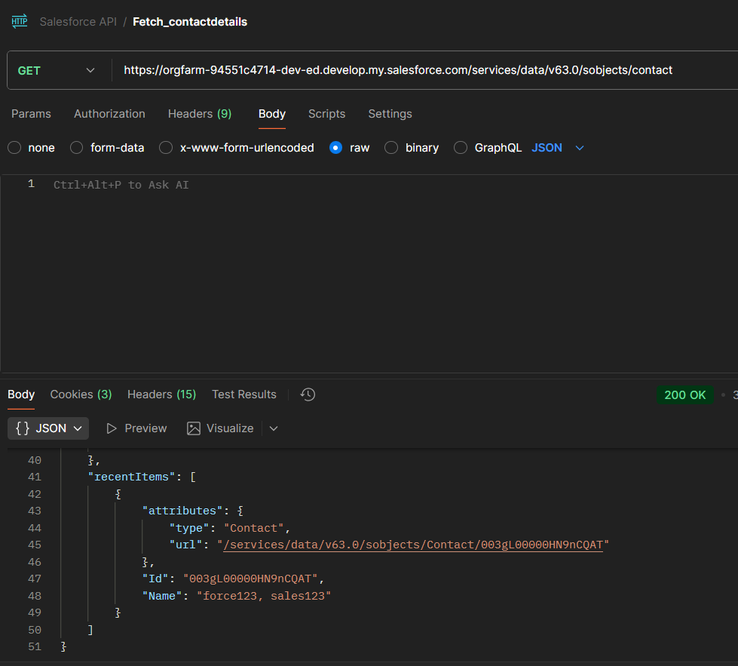

Patch:
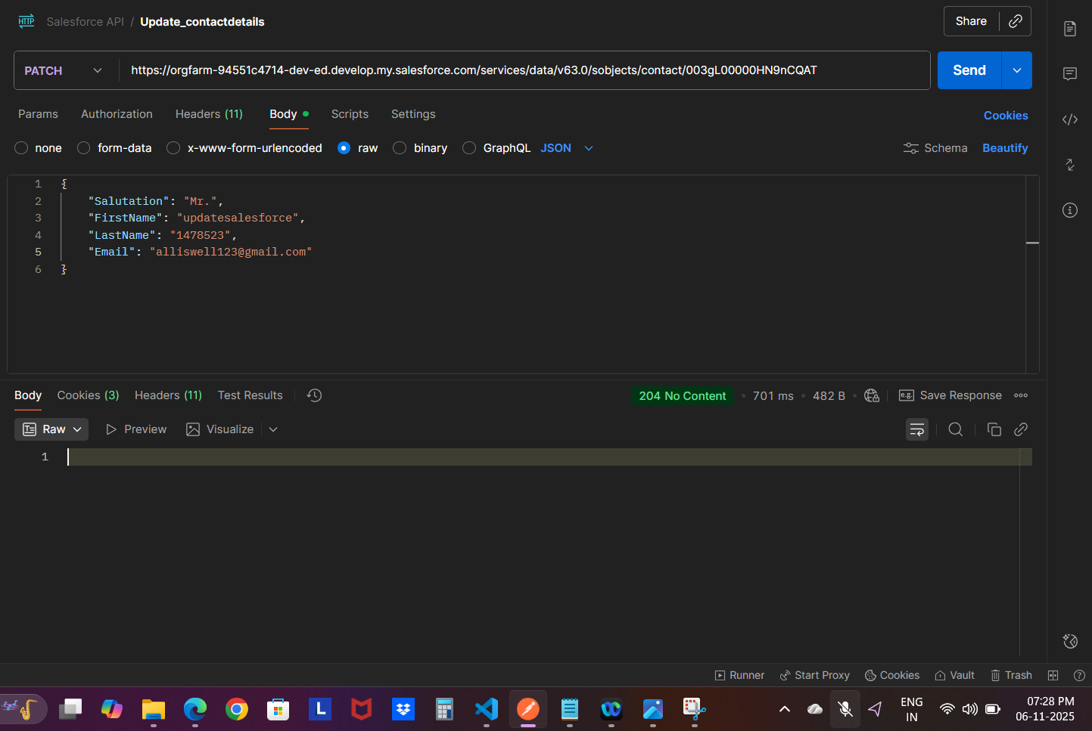
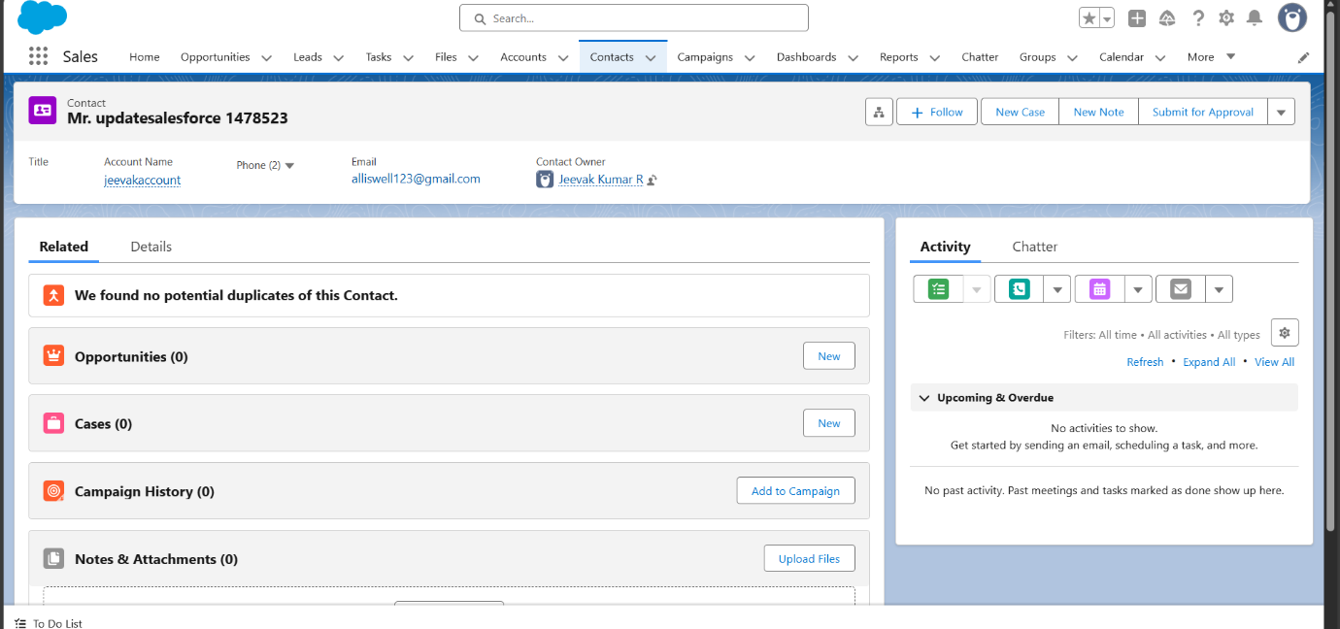

Delete:
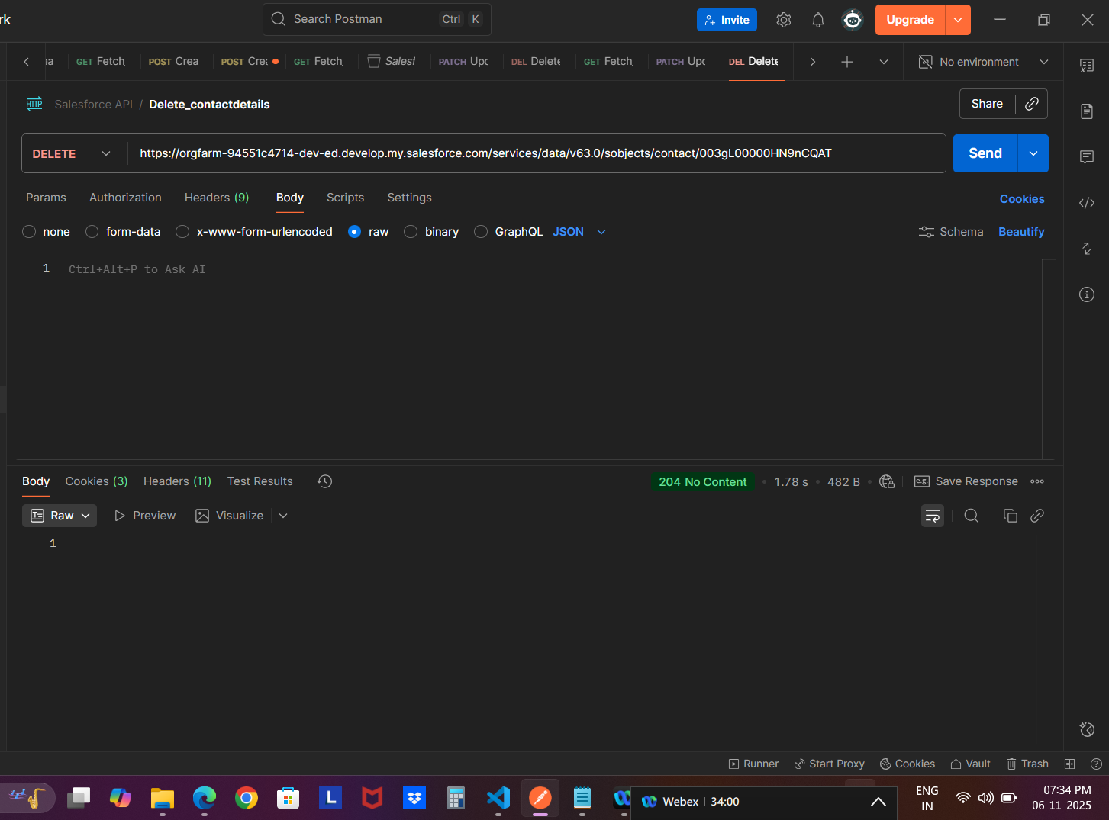

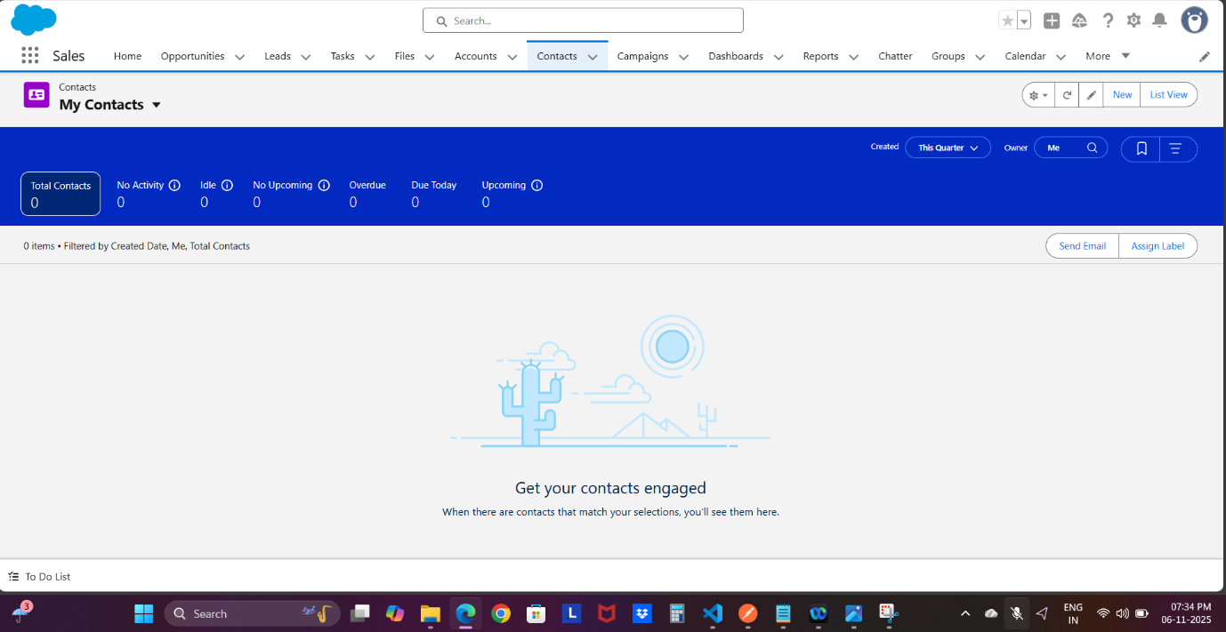

Playwright API: Get, Update, Delete
Get:
Before updating:
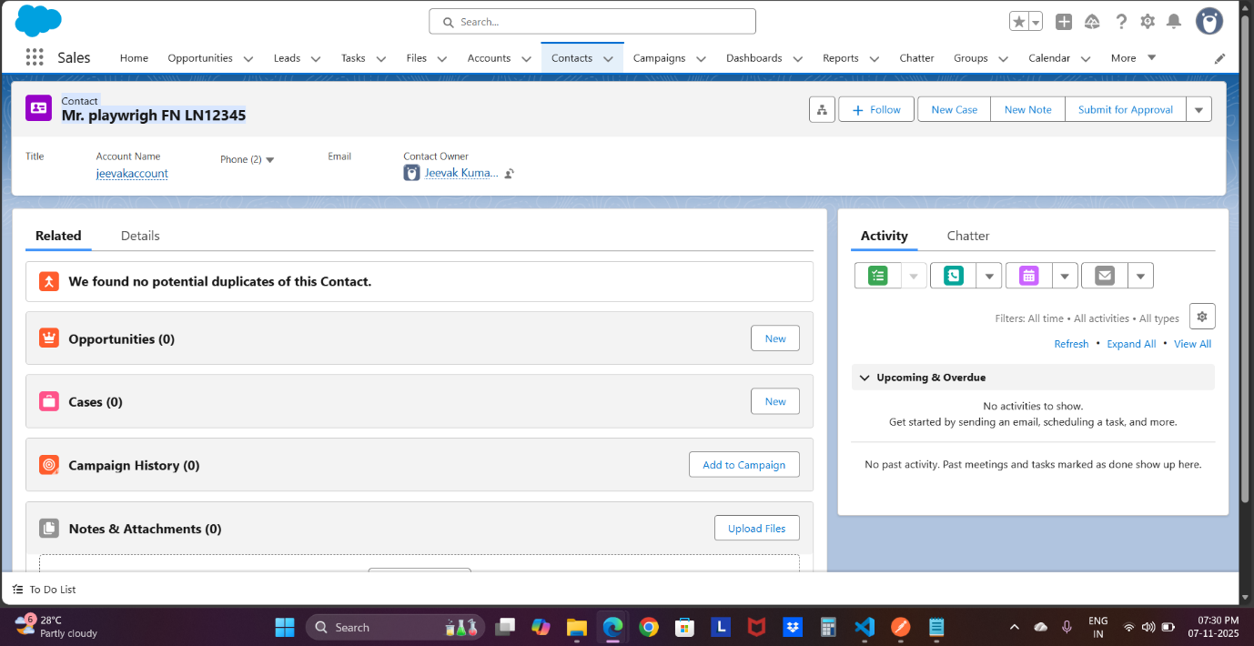

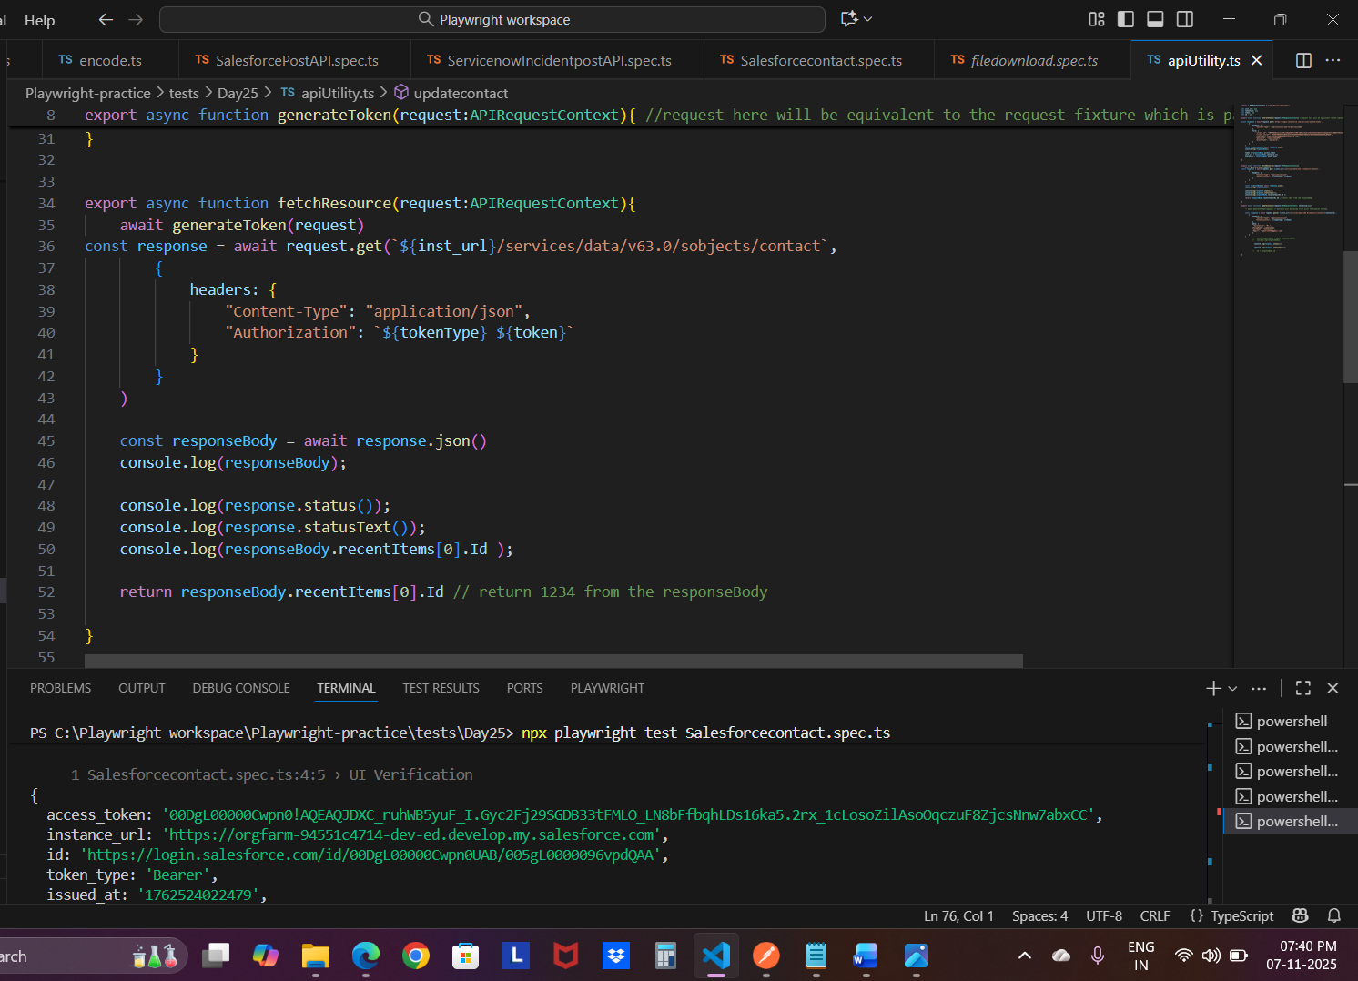

Patch:
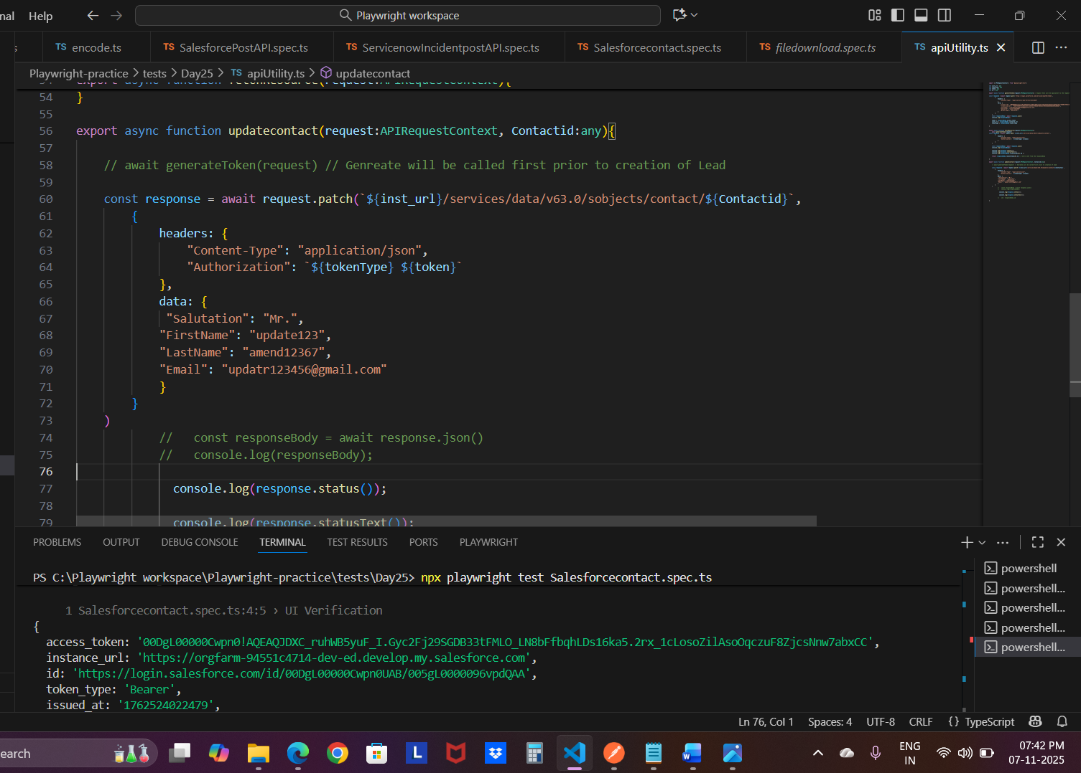
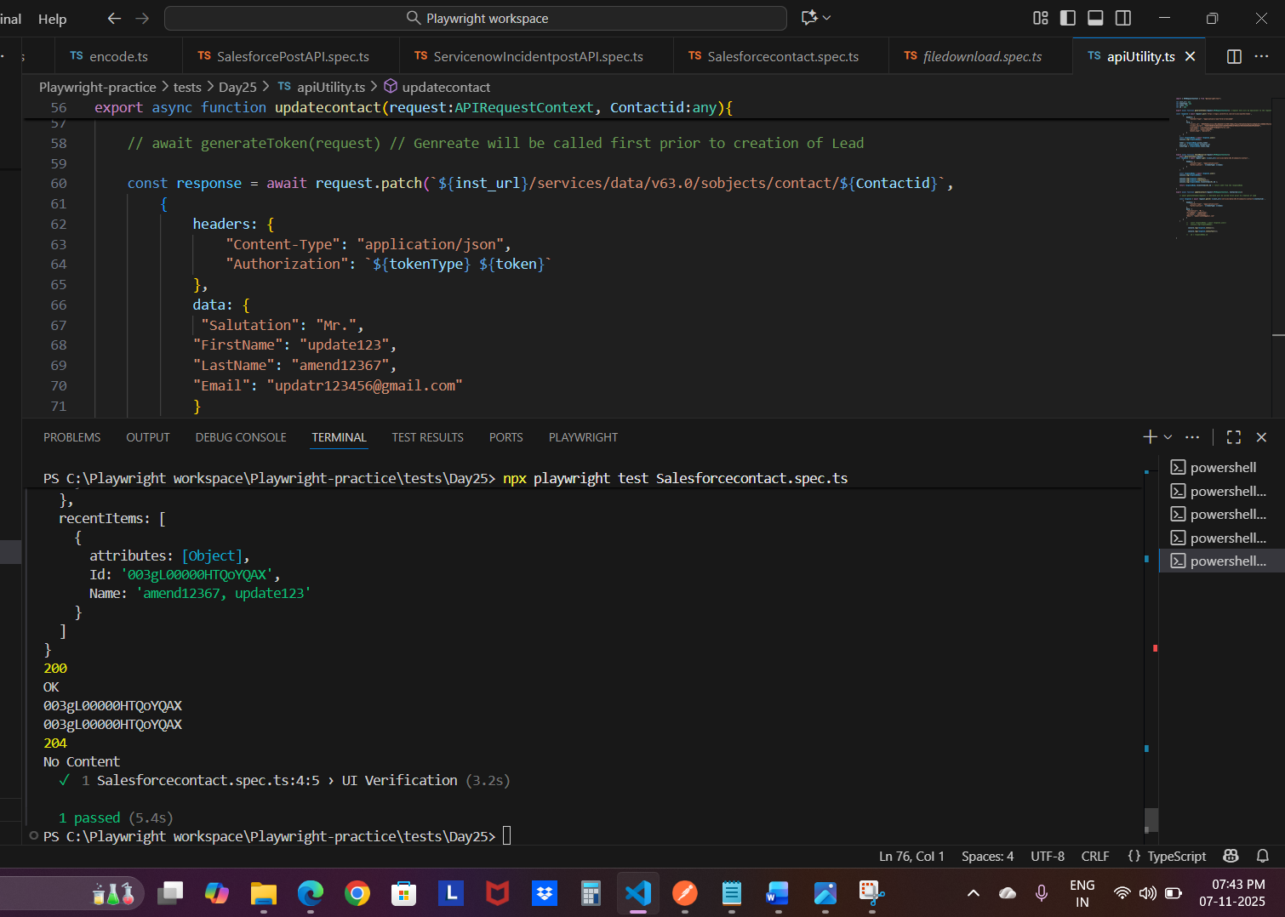
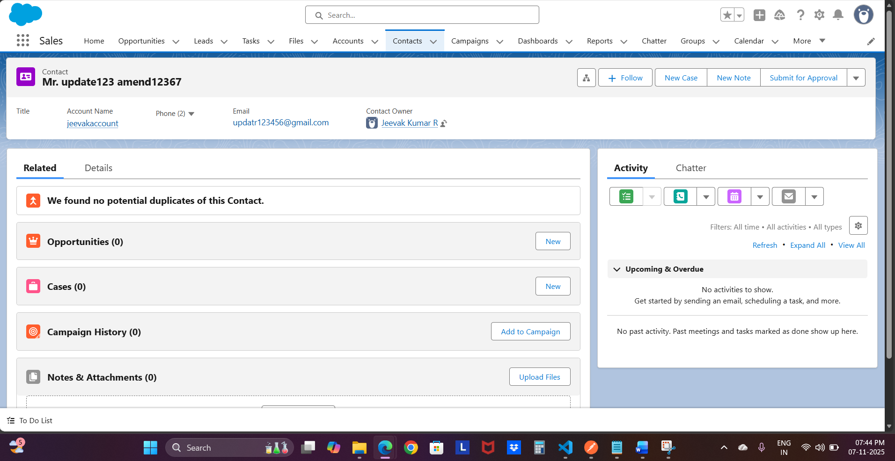
Delete:
Updated 2^{nd,3rd,4th} time not working: going to try 5th time
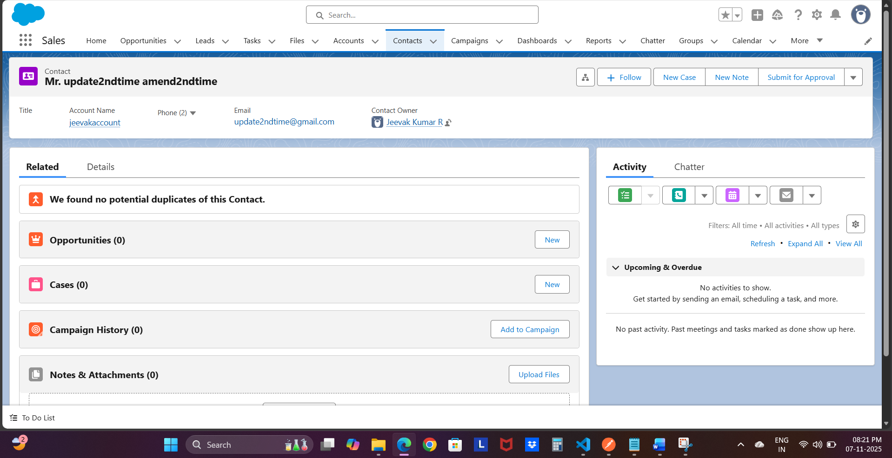5th time delete: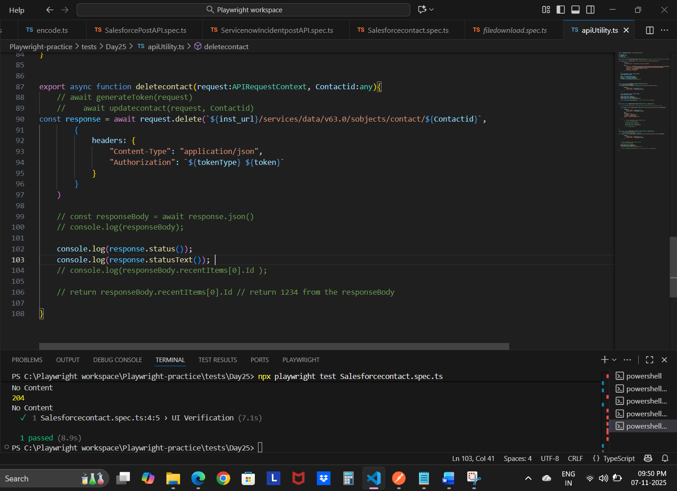
Token generation:
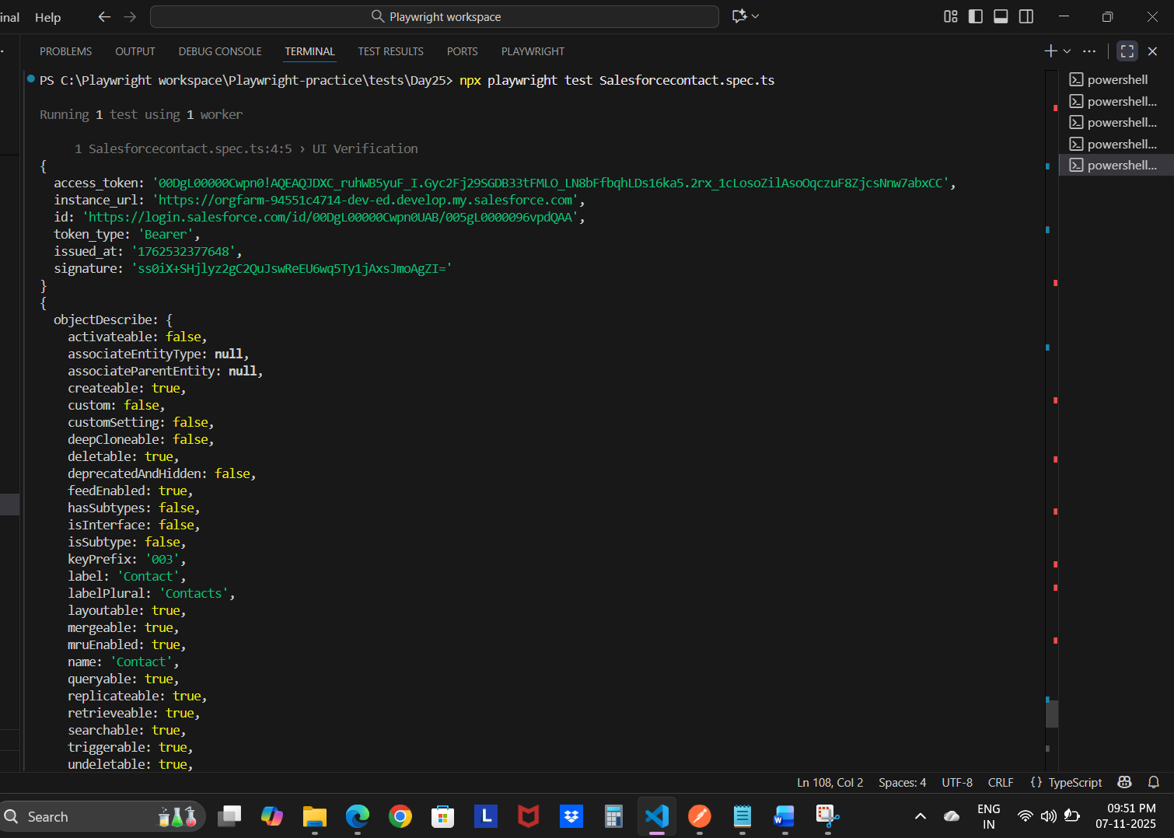
Fetch, patch, delete
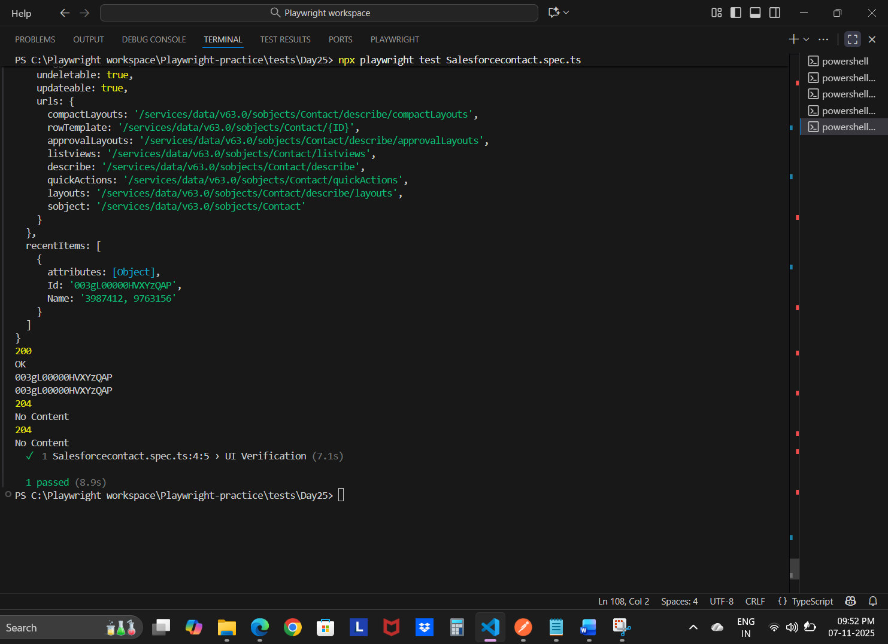
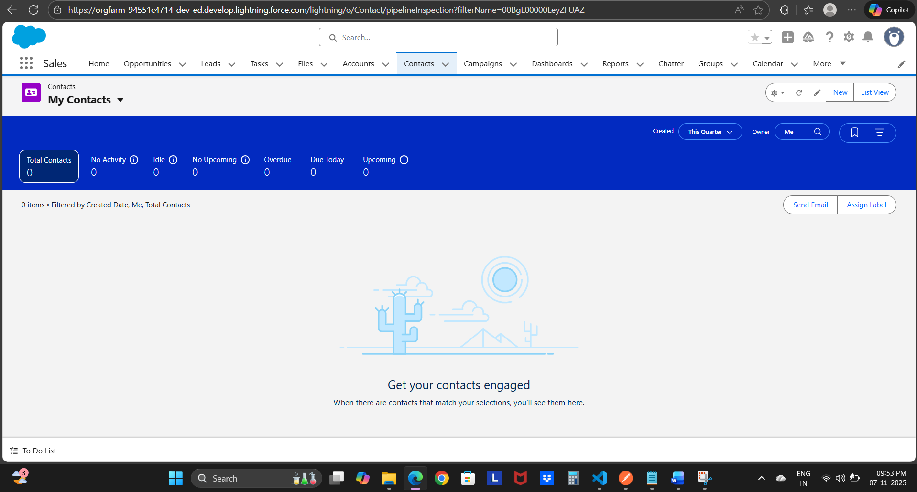

My code :
import { APIRequestContext } from "@playwright/test";
let inst_url: any
let tokenType: any
let token: any
// let Contactid : any
export async function generateToken(request:APIRequestContext){ //request here will be equivalent to the request fixture which is parameter from the .spec.ts
const response = await request.post(`https://login.salesforce.com/services/oauth2/token`,
{
headers: {
"Content-Type": "application/x-www-form-urlencoded"
},
form: {
"client_id": "--",
"client_secret": "---",
"username": "reachmejeevak07752@agentforce.com",
"password": "--",
"grant_type": "password",
}
}
)
const responseBody = await response.json()
console.log(responseBody);

token = responseBody.access_token
inst_url = responseBody.instance_url
tokenType = responseBody.token_type
// Contactid =responseBody.recentItems[0].Id

}

export async function fetchResource(request:APIRequestContext){
await generateToken(request)
const response = await request.get(`${inst_url}/services/data/v63.0/sobjects/contact`,
{
headers: {
"Content-Type": "application/json",
"Authorization": `${tokenType} ${token}`
}
}
)

const responseBody = await response.json()
console.log(responseBody);

console.log(response.status());
console.log(response.statusText());
console.log(responseBody.recentItems[0].Id );

return responseBody.recentItems[0].Id // return 1234 from the responseBody

}

export async function updatecontact(request:APIRequestContext, Contactid:any){

// await generateToken(request) // Genreate will be called first prior to creation of Lead

const response = await request.patch(`${inst_url}/services/data/v63.0/sobjects/contact/${Contactid}`,
{
headers: {
"Content-Type": "application/json",
"Authorization": `${tokenType} ${token}`
},
data: {
"Salutation": "Mr.",
"FirstName": "update5thtime",
"LastName": "amend5thtime",
"Email": "update5thtime@gmail.com"
}
}
)
// const responseBody = await response.json()
// console.log(responseBody);

console.log(response.status());

console.log(response.statusText());

// id = responseBody.id

}

export async function deletecontact(request:APIRequestContext, Contactid:any){
// await generateToken(request)
// await updatecontact(request, Contactid)
const response = await request.delete(`${inst_url}/services/data/v63.0/sobjects/contact/${Contactid}`,
{
headers: {
"Content-Type": "application/json",
"Authorization": `${tokenType} ${token}`
}
}
)

// const responseBody = await response.json()
// console.log(responseBody);

console.log(response.status());
console.log(response.statusText());
// console.log(responseBody.recentItems[0].Id );

// return responseBody.recentItems[0].Id // return 1234 from the responseBody

}

